Calculator Free
Trigonometric Functions and Trigonometric Identities

Time: 45 minutes
Total Marks: 45
Your Score: / 45



Question One: [2, 3, 3 =8 marks]

Describe the transformations that have transformed to in the situation below.

Question Two: [2, 3, 3, 4 = 12 marks]

Sketch each of the following functions on the axes below:

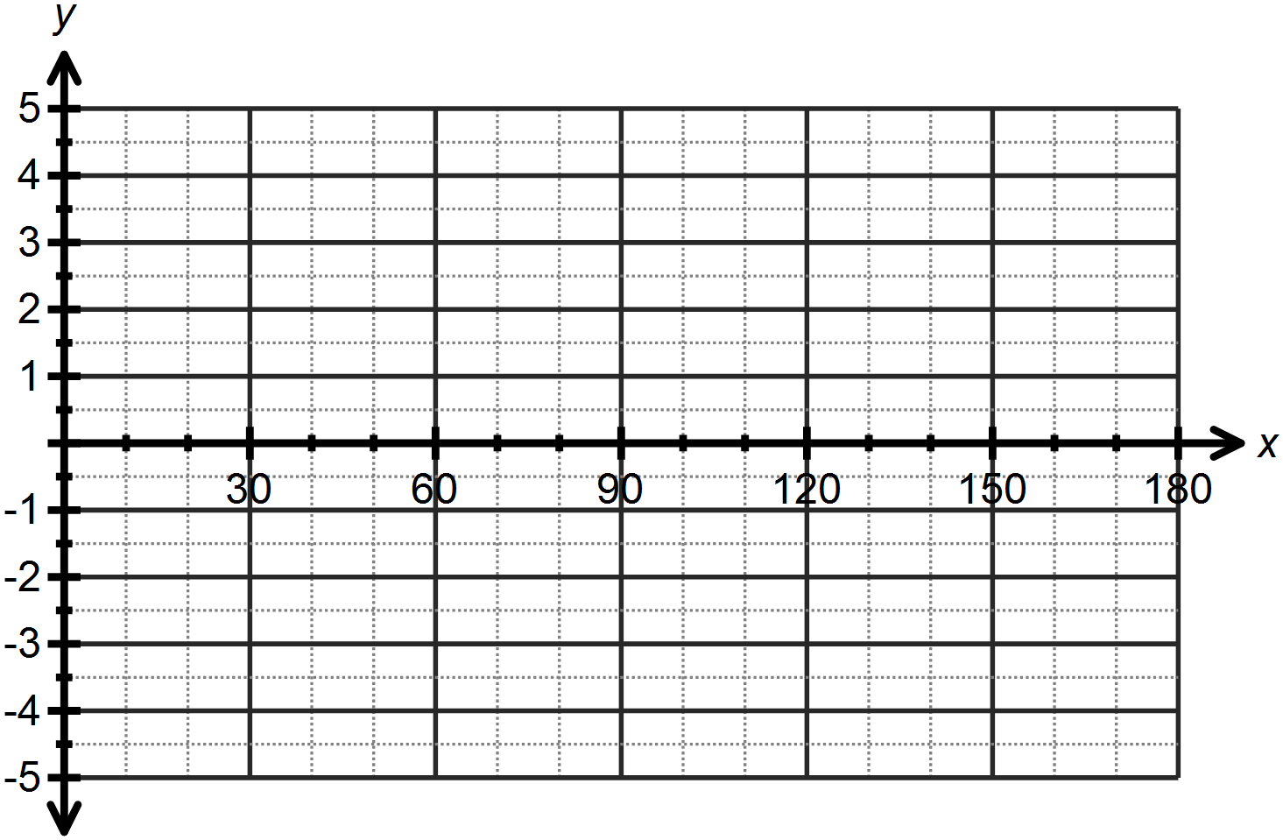

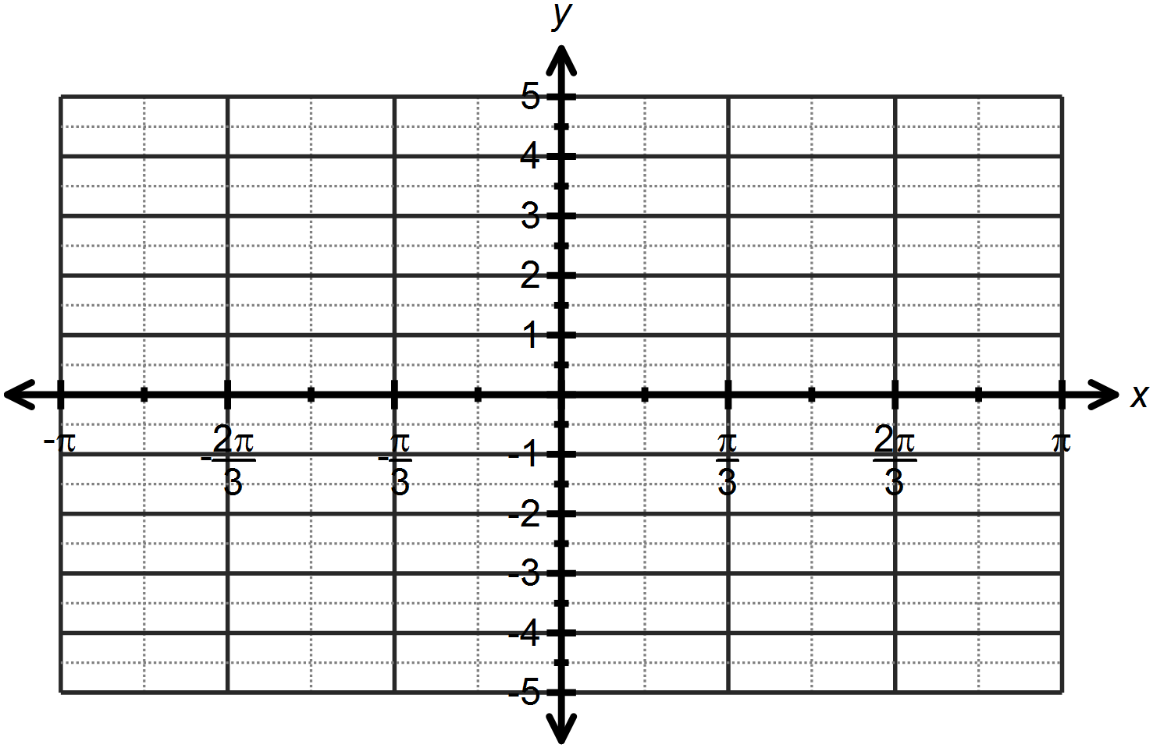

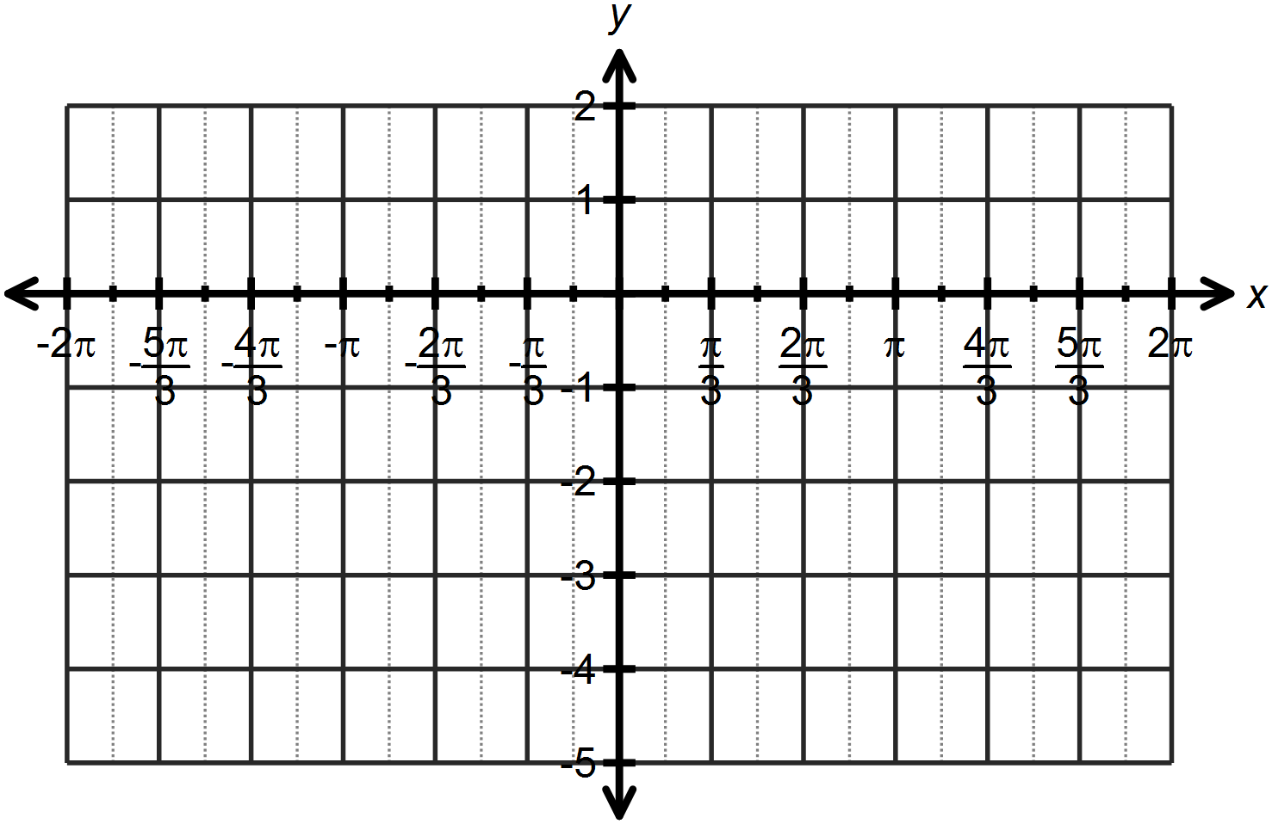

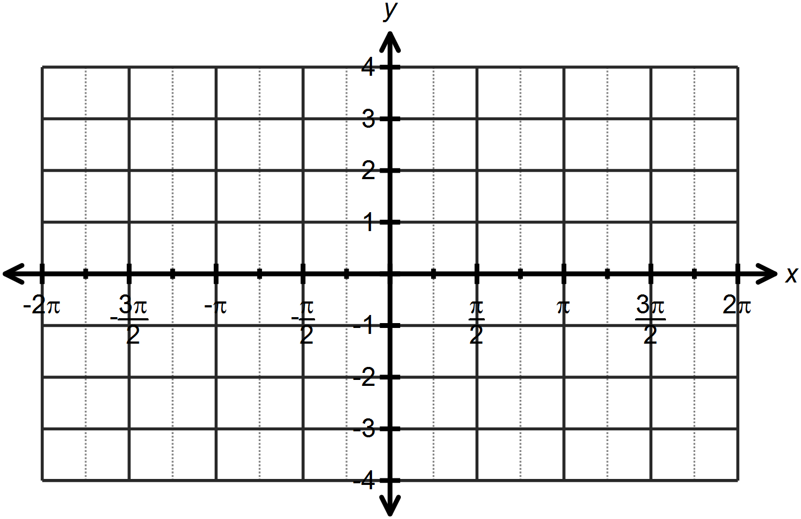

Question Three: [2, 2, 2 = 6 marks]

Calculate the values of the unknowns for each of the following:

Question Four: [5 marks]

Determine the equation of the graph drawn below as both a sine and a cosine function.

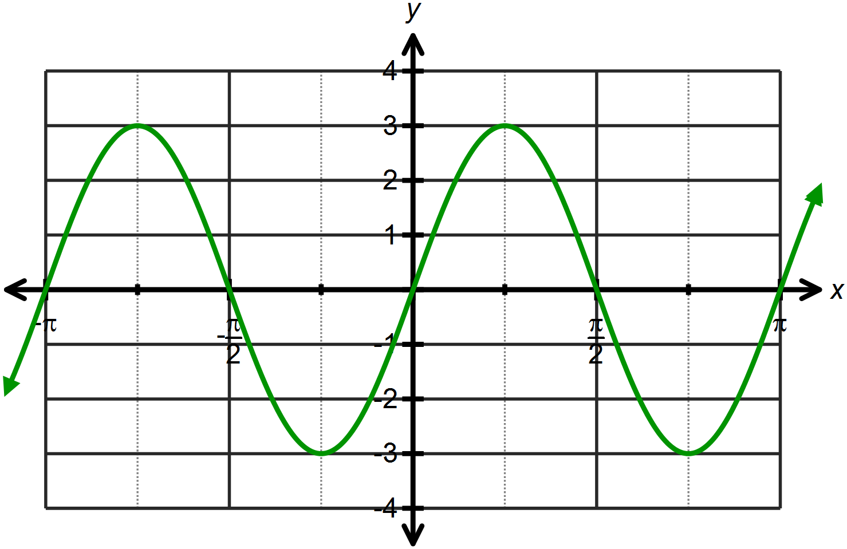

Question Five: [3, 3, 4, 4 = 14 marks]

Use the angle sum or difference property to find the exact value for each of the following, simplifying all answers.

SOLUTIONS
Calculator Free
Trigonometric Functions and Trigonometric Identities

Time: 45 minutes
Total Marks: 45
Your Score: / 45



Question One: [2, 3, 3 =8 marks]

Describe the transformations that have transformed to in each situation below.


Horizontal dilation scale factor ½

Vertical dilation scale factor 3



Translate units right
Reflect about the x – axis

Translate 1 unit up



Horizontal translation left
Horizontal dilation scale factor 2

Question Two: [2, 3, 3, 4 = 12 marks]

Sketch each of the following functions on the axes below:

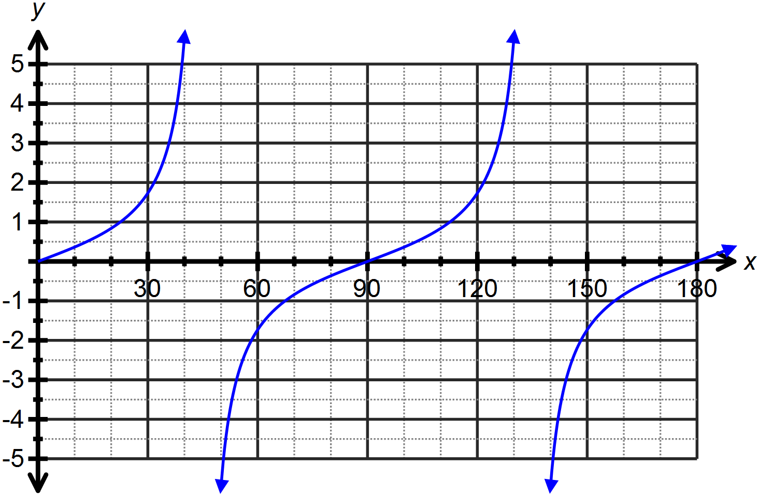




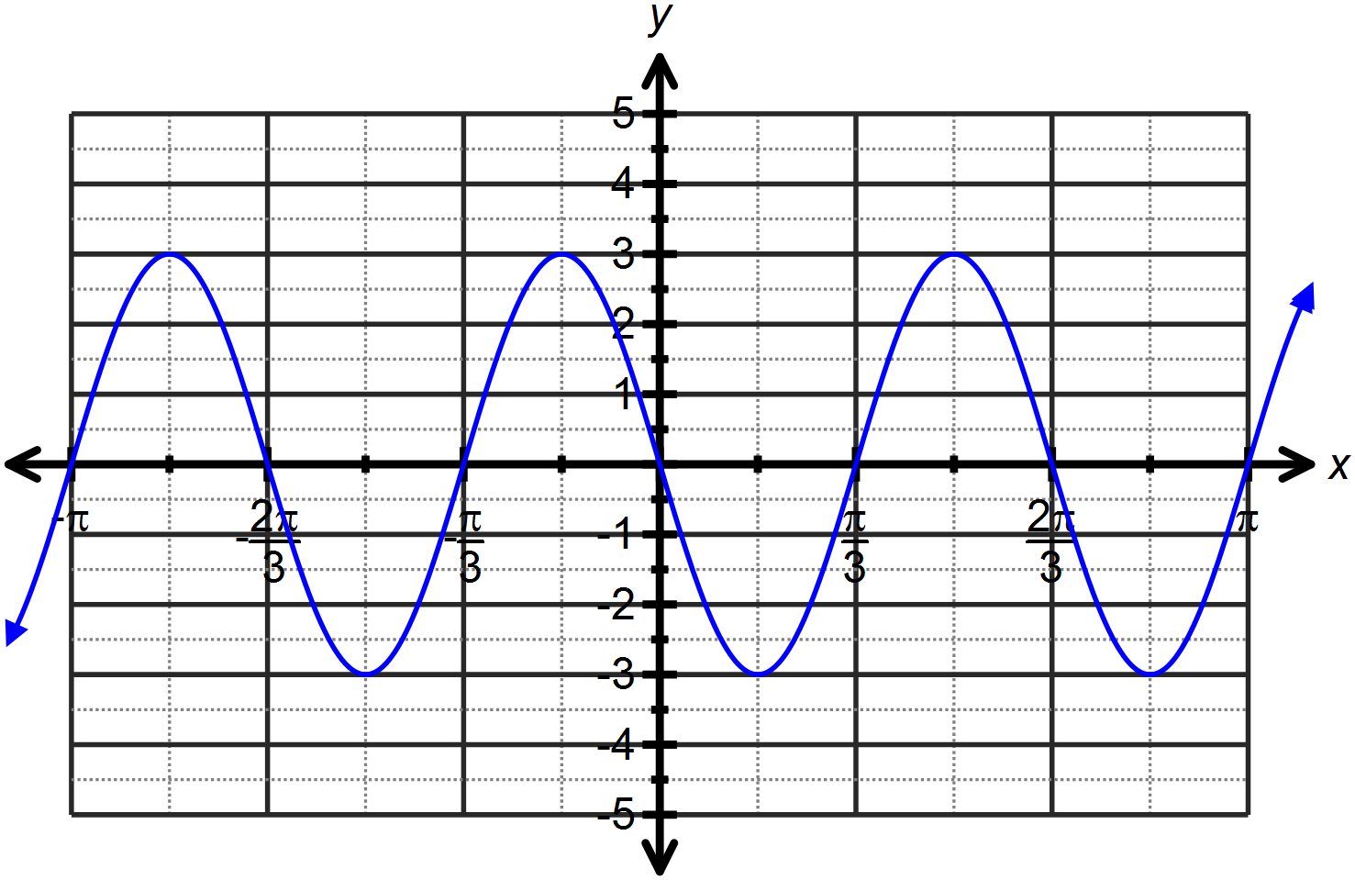






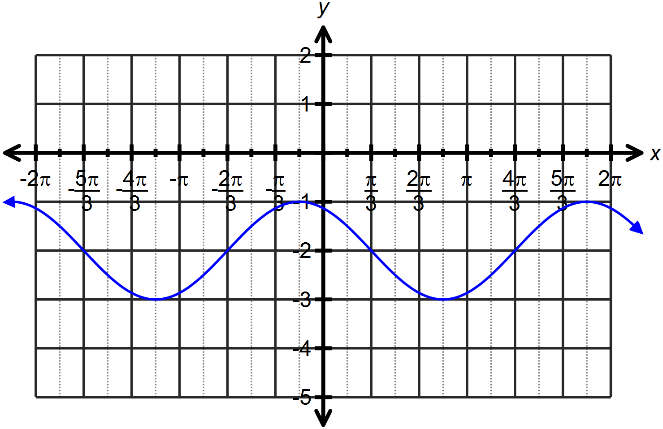






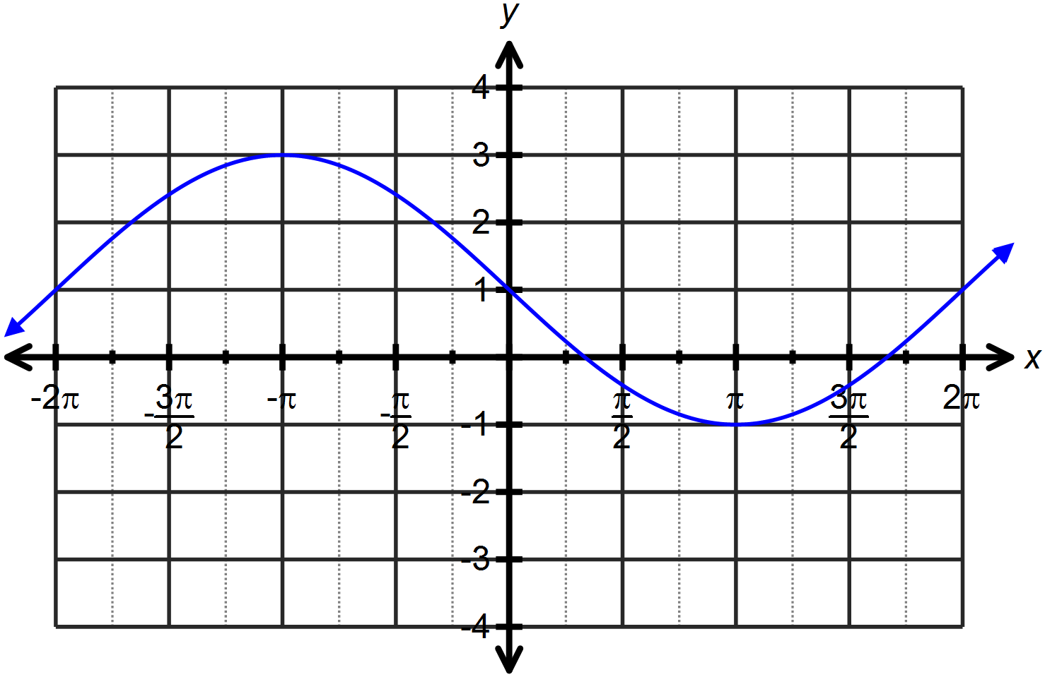








Question Three: [2, 2, 2 = 6 marks]

Calculate the values of the unknowns for each of the following:










Question Four: [5 marks]

Determine the equation of the graph drawn below as both a sine and a cosine function.








Question Five: [3, 3, 4, 4 = 14 marks]

Use the angle sum or difference property to find the exact value for each of the following, simplifying all answers.



















